**BRIAN GITONGA**

**C027-01-1129/2021**

**BACHELOR OF SCIENCE IN BUSINESS INFORMATION TECHNOLOGY CAPSTONE PROJECT**

**A PHOTOGRAPHIC ESSAY ON ANY IMPORTANT ISSUE YOU MAY IDENTIFY IN THE AFRICAN COMMUNITY**

**Title: Quality Education in the African Community: Bridging the Gap** 

**Introduction:**

Quality education is a fundamental right and a key driver of social and economic development. However, within the African community, there exists a persistent issue of inadequate access to and provision of quality education. This essay aims to shed light on the challenges faced by African communities in attaining quality education and explore potential solutions to bridge the gap.

**Historical Context and Colonial Legacy**

The issue of quality education in Africa cannot be discussed without considering the historical context and the lingering effects of colonialism. The colonial legacy left behind a fragmented education system that perpetuated inequalities and failed to address the unique needs of African communities.

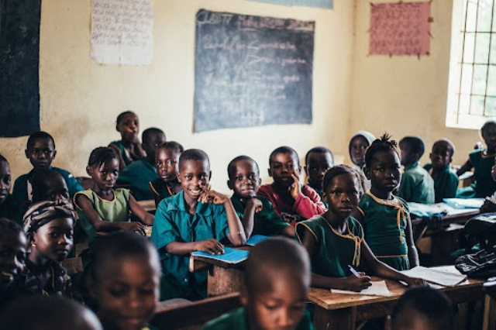**Limited Infrastructure and Resources**

One of the primary challenges to quality education in the African community is the lack of adequate infrastructure and resources. Many schools suffer from overcrowded classrooms, a shortage of textbooks, inadequate teaching materials, and insufficient facilities, hindering effective learning.

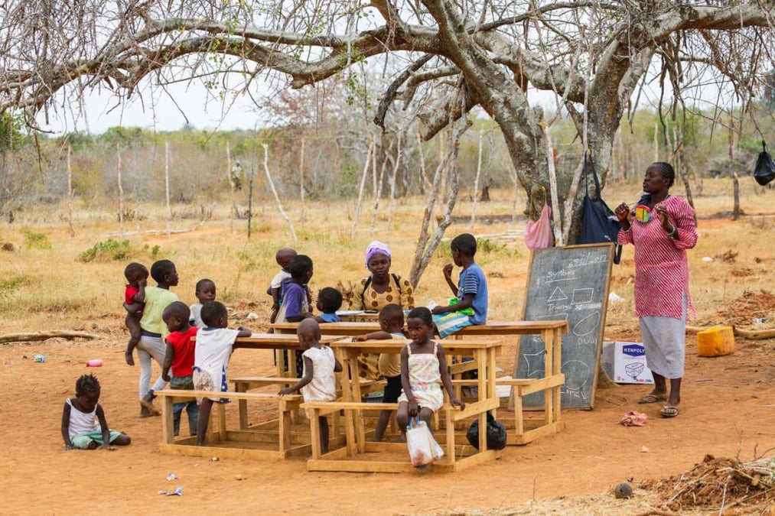

**Teacher Shortages and Low Remuneration**

African communities often face a shortage of qualified and motivated teachers. Low salaries, limited professional development opportunities, and challenging working conditions contribute to teacher shortages, impacting the quality of education provided students.

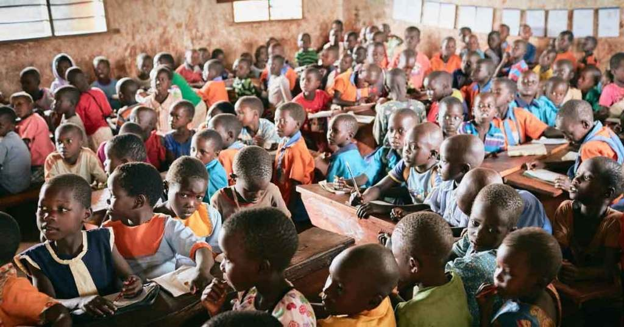

**Gender Disparities in Education**

Gender disparities in education persist in many African communities, with girls facing significant barriers to accessing quality education. Factors such as early marriage, cultural norms, and household responsibilities often hinder girls' enrollment and retention in schools.

**Inadequate Access to Early Childhood Education**

Early childhood education plays a crucial role in a child's development, yet many African communities lack access to quality preschools and early learning programs. This lack of early childhood education opportunities contributes to educational inequalities later in life.

**Language Barriers and Inclusive Education**

Language barriers pose a significant challenge to quality education in many African communities. The mismatch between the language of instruction and students' mother tongues hampers effective learning and inclusive, particularly for marginalized groups. 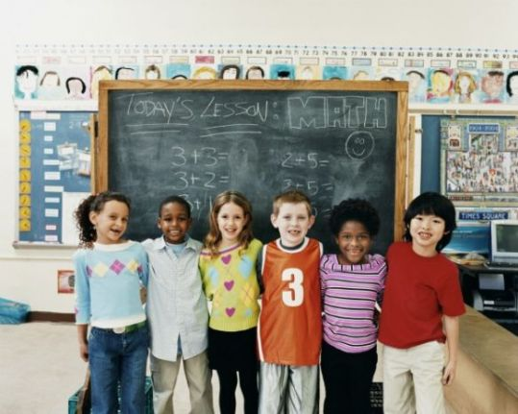

**Insufficient Investment in Education**

African countries often face budgetary constraints and limited investment in the education sector. Insufficient funding leads to inadequate infrastructure, inadequate teacher training, and a lack of educational resources, perpetuating the cycle of poor-quality education.

**Socioeconomic Disparities and Education**

Socioeconomic disparities further exacerbate the issue of quality education in African communities. Children from economically disadvantaged backgrounds often lack access to educational opportunities, perpetuating the cycle of poverty and inequality.

**SOLUTIONS**



**Role of Technology in Education**

Harnessing technology can be a potential solution to overcome some of the challenges in quality education. Integrating digital tools, online resources, and e-learning platforms can enhance access to educational materials and bridge the gap between rural and urban areas.

**Strengthening Teacher Training and Professional Development**

Investing in comprehensive teacher training programs and providing ongoing professional development opportunities can improve the quality of education. Equipping teachers with modern teaching methodologies and pedagogical skills will enhance their effectiveness in the classroom.

**Promoting Gender Equality in Education**

Fostering a supportive environment that promotes gender equality in education is crucial. This involves initiatives to address cultural biases, provide scholarships for girls, and implement policies that protect against gender-based discrimination.

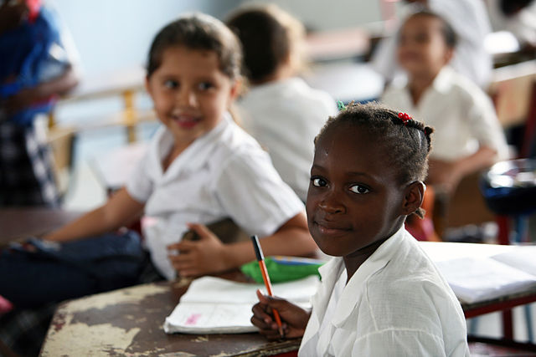

**Enhancing Early Childhood Education**

Expanding access to quality early childhood education programs will lay a strong foundation for lifelong learning. Governments and stakeholders must prioritize investment in early childhood education to ensure all children have equal opportunities for success.

**Strengthening Education Governance and Accountability**

Improving education governance and accountability mechanisms is essential for addressing the issue of quality education. Transparent and efficient management of education systems, coupled with robust monitoring and evaluation frameworks, can drive positive change.

**Promoting Partnerships and Collaboration**

Addressing the issue of quality education in the African community requires collaboration among governments, civil society organizations, and international partners. By working together, stakeholders can pool resources, share best practices, and implement sustainable solutions.

**Conclusion**

The issue of quality education in the African community is complex and multifaceted. However, by addressing challenges such as limited infrastructure, teacher shortages, gender disparities, and inadequate investment, it is possible to bridge the gap. Through concerted efforts, inclusive policies, and targeted interventions, African communities can provide quality education that empowers individuals, fosters socioeconomic development, and paves the way for a brighter future.

